

**CS-114 - Fundamental of Programing**

**Lab Manual # 7**

**Lab Task**

Submitted To: Engr Muhammad Affan

Submitted By: Shahzaib Murtaza (466034)

Section: B

**1. Take 10 integer inputs from user and store them in an array and print them on screen.**

#include<iostream>

using namespace std;

int main(){

int arr[9];

for (int i=0; i<10; i++){

cout <<"Enter integer:";

cin>>arr [i];

}

for(int i=0;i<10;i++)

{

cout <<arr [i]<<"\t";

}

return 0;

}

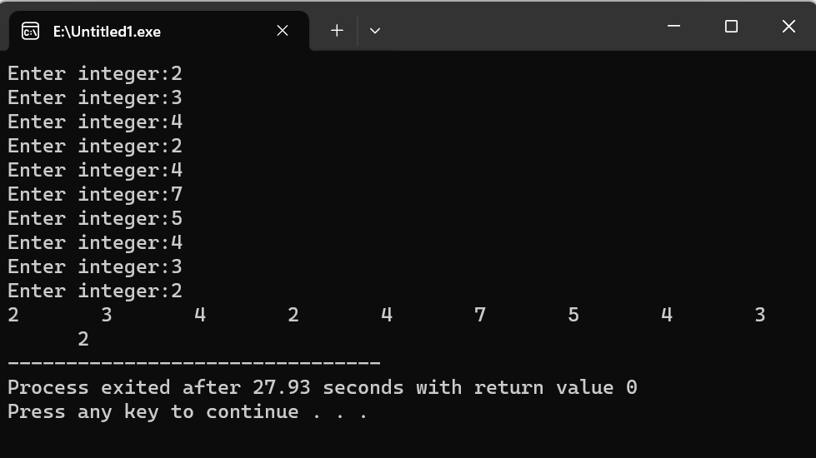

**2. Write a program to find the sum and product of all elements of an array with 5 integer elements.**

#include<iostream>

using namespace std;

int main(){

int arr[]={3,4,5,7,8};

int product=1,sum=0;

for (int i=0; i<5; i++){

product=product*arr[i];

sum=sum+arr[i];

}

cout<<"Product:"<<product<<endl;

cout<<"Sum:"<<sum<<endl;

return 0;

}

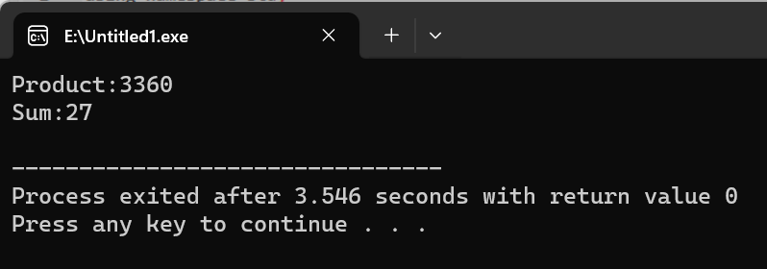

**3. Print diamond pattern using a single array.**

#include <iostream>

using namespace std;

int main() {

int middlerow;

cout << "Enter number of lines:";

cin >> middlerow;

cout << endl;

int size;

size = 2 * middlerow - 1;

char diamond[size + 1] = {};

for (int i = 0; i < size; ++i) {

diamond[i] = ' ';

}

for (int i; i < middlerow; ++i) {

diamond[middlerow - i] = '*';

diamond[middlerow + i] = '*';

for (int j = 0; j <= size; ++j) {

cout << diamond[j];

}

cout << endl;

}

for (int i = middlerow - 1; i > 0; --i) {

diamond[middlerow - i] = ' ';

diamond[middlerow + i] = ' ';

for (int j = 0; j <= size; ++j) {

cout << diamond[j];

}

cout << endl;

}

return 0;

}

